* Copyright for test papers and marking guides remains with *West Australian Test Papers*.
* The papers may only be reproduced within the purchasing school according to the advertised conditions of sale.
* Test papers must be withdrawn after use and stored securely in the school until Friday 11th June, 2021.

**HUMAN BIOLOGY**

**Unit 1**

**2021**



Name: _______________________________________________________

Teacher: ___________________________________________________

**Time allowed for this paper**

Reading time before commencing work: ten minutes

Working time: three hours

**Materials required/recommended for this paper**

***To be provided by the supervisor***

This Question/Answer booklet

Multiple-choice answer sheet

***To be provided by the candidate***

Standard items: pens (blue/black preferred), pencils (including coloured), sharpener, correction fluid/tape, eraser, ruler, highlighters

Special items: up to three calculators, which do not have the capacity to create or store programmes or text, are permitted in this ATAR course examination

**Important note to candidates**

No other items may be taken into the examination room. It is **your** responsibility to ensure that you do not have any unauthorised material. If you have any unauthorised material with you, hand it to the supervisor **before** reading any further.

**Structure of this paper**

|  |  |  |  |  |  |
| --- | --- | --- | --- | --- | --- |
| Section | Number of questions available | Number of questions to be attempted | Suggested working time (minutes) | Marks available | Percentage of examination |
| Section One  Multiple-choice | 30 | 30 | 40 | 30 | 30 |
| Section Two  Short answer | 7 | 7 | 90 | 107 | 50 |
| Section Three  Extended answer  Part 1  Part 2 | 2 | 1 | 50 | 40 | 20 |
| 2 | 1 |
|  |  |  |  | **Total** | 100 |

**Instructions to candidates**

1. The rules for the conduct of the Western Australian external examinations are detailed in the *Year 12 Information Handbook 2021*. Sitting this examination implies that you agree to abide by these rules.

2. Write your answers in this Question/Answer booklet preferably using a blue/black pen. Do not use erasable or gel pens.

3. Answer the questions according to the following instructions.

Section One: Answer all questions on the separate Multiple-choice answer sheet provided. For each question, shade the box to indicate your answer. Use only a blue or black pen to shade the boxes. Do not use erasable or gel pens. If you make a mistake, place a cross through that square, then shade your new answer. Do not erase or use correction fluid/tape. Marks will not be deducted for incorrect answers. No marks will be given if more than one answer is completed for any question.

Section Two: Write your answers in this Question/Answer booklet. Wherever possible, confine your answers to the line spaces provided.

Section Three: Consists of two parts each with two questions. You must answer one question from each part. Tick the box next to the question you are answering. Write your answers in this Question/Answer booklet.

4. You must be careful to confine your answers to the specific questions asked and to follow any instructions that are specific to a particular question.

5. Supplementary pages for planning/continuing your answers to questions are provided at the end of this Question/Answer booklet. If you use these pages to continue an answer, indicate at the original answer where the answer is continued, i.e. give the page number.

**Section One: Multiple-choice 30% (30 Marks)**

This section has **30** questions. Answer **all** questions on the separate Multiple-choice answer sheet provided. For each question shade the box to indicate your answer. Use only a blue or black pen to shade the boxes. Do not use erasable or gel pens. If you make a mistake, place a cross through that square, then shade your new answer. Do not erase or use correction fluid/tape. Marks will not be deducted for incorrect answers. No marks will be given if more than one answer is completed for any question.

Suggested working time: 40 minutes.

1. Cardiac muscle cells are joined end to end by structures known as
   1. **intercalated discs.**
   2. sarcomeres.
   3. synapses.
   4. striations.
2. The test for Covid-19 analyses samples for the presence of antibodies in the body. The cells, which produce these antibodies and act to protect the body from foreign invaders, are known as
   1. thrombocytes.
   2. erythrocytes.
   3. platelets.
   4. **leucocytes.**
3. Sebaceous glands in our skin secrete an oily substance known as sebum that contains lipids. Which cell organelle would you expect to find in high numbers within the cells of these glands?
   1. Ribosomes
   2. Mitochondria
   3. **Smooth endoplasmic reticulum**
   4. Golgi body
4. The human diet contains acid producing foods. Which of the following occur to hydrogen and ammonium ions in the kidney to maintain blood pH within its normal range of 7.4-7.5?
   1. **Both would be secreted into the filtrate.**
   2. Both would be reabsorbed into the filtrate.
   3. Only hydrogen would be secreted into the filtrate.
   4. Only ammonium ions would be reabsorbed into the filtrate.

Questions 5 - 7 refer to the diagram below of a person undertaking a common exercise known as a bicep curl.

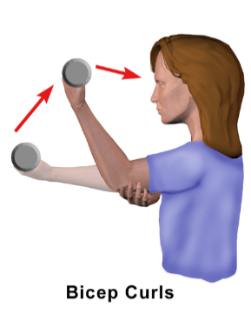

1. What motion is shown by the bicep curl?
   1. Extension
   2. Rotation
   3. **Flexion**
   4. Abduction
2. Which of the following structures connects the bones of the arm together to help stabilise the motion of the bicep curl?
   1. Tendons
   2. **Ligaments**
   3. Insertions
   4. Joints
3. As the bicep muscle contracts, the tricep muscle will relax. These pair of muscles are referred to as
   1. **antagonists.**
   2. agonists.
   3. prime movers.
   4. extensors.
4. The two sets of convolutions in the nephron allows for
   1. decreased concentration gradients for better reabsorption.
   2. **an increase in surface area for reabsorption and secretion.**
   3. a rise in blood pressure for increased filtration.
   4. minimal loss of filtrate during urine production.
5. The function of the cilia found in the epithelial cells of the trachea is to help move
   1. **mucus and debris out of the lungs.**
   2. air into the bronchioles.
   3. mucus into the lower respiratory tracts.
   4. air out of the mouth and nose.

Question 10 refers to the following graph showing the activity of an enzyme over a range of temperatures.

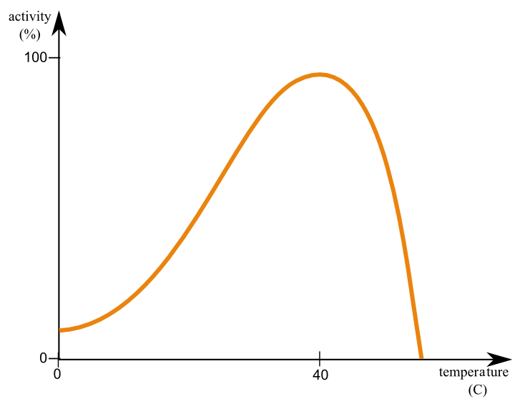

1. Which of the following explains the reduction in enzyme activity in the graph shown above?
   1. Action of inhibitors increases
   2. Substrates begin to break down
   3. **Active site changes shape**
   4. Product concentration increases
2. During a scientific investigation, several trials are run. Which of the following is the **best** reason to explain this?
   1. Increase validity
   2. **Reduce effect of random errors**
   3. For the scientist to improve their skills
   4. Increase accuracy
3. Which of the following is **not** an example of an appendicular bone?
   1. Humerus
   2. Fibula
   3. **Vertebrae**
   4. Pelvis
4. A typical pair of adult human lungs contains 480 million alveoli. The reason for this high number is to
   1. **increase surface area for gas exchange.**
   2. increase the number of muscles to breath.
   3. maintain the shape and keep the lungs inflated.
   4. decrease pressure allowing air to be inspired.
5. Familial hypercholesterolemia results from the failure of specific receptors on the cell membrane. The receptors allow low-density lipoproteins to be engulfed and ultimately lowers blood cholesterol levels. Patients suffering this genetic disorder are at risk of cardiovascular disease. The movement of these lipoproteins into the cells is **best** known as
   1. facilitated transport.
   2. exocytosis.
   3. active transport.
   4. **endocytosis.**

Question 15 refers to the diagram below of a human skull.

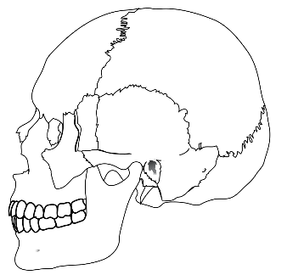

1. The irregular lines on the skull indicate where different bones join. What is the name given to this type of joint found in the skull?

* 1. Synovial
  2. **Fibrous**
  3. Cartilaginous
  4. Plate

Question 16 refers to the diagram below that shows a sample of epithelial tissue.

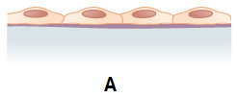

1. In which of the following structures would you expect to find this type of epithelial tissue?
   1. Oesophagus, to protect from abrasions whilst breathing
   2. Urethra, to allow for expansion during excretion
   3. Distal convoluted tubule, allowing for secretion and absorption
   4. **Lymphatic vessels, to allow materials to pass via diffusion**
2. The enzyme found in the human mouth starts the digestion of carbohydrates. Which of the following **correctly** identifies the name and optimal pH for this enzyme?
   1. Amylase; pH 5
   2. Maltase; pH 9
   3. **Amylase; pH 7**
   4. Maltase; pH 5

Questions 18 and 19 refer to the diagram below of a unit of muscle fibre.

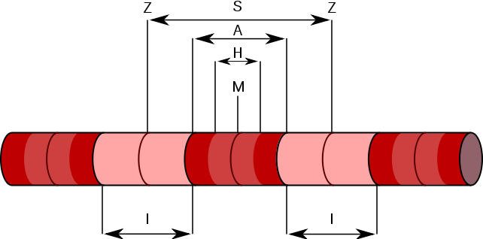

1. Which of the following are located in the zone indicated by the letter H?
   1. Actin only
   2. **Myosin only**
   3. Actin and myosin
   4. Calcium ion receptors
2. What happens to the zone indicated by the letter A when muscles contract?
   1. **Stays the same width**
   2. Decreases in width as actin slides over myosin
   3. Increases in width as actin slides over myosin
   4. Decreases in width as myosin slides over actin
3. Which of the following tissue types would **not** be classified in the same category as bone?
   1. Adipose tissue
   2. Fibrocartilage
   3. Blood
   4. **Muscle**
4. Which of the following statements **correctly** identifies the difference between elimination and excretion?
   1. Excretion occurs mainly through faeces, whilst elimination occurs through urine.
   2. Excretion removes indigestible material, whilst elimination removes metabolic wastes only.
   3. Elimination occurs in several different organs, whilst excretion occurs only in the kidneys.
   4. **Elimination is the removal of indigestible material and metabolic waste, whilst excretion removes metabolic wastes only.**

Question 22 refers to the diagram below that illustrates a section of bone.

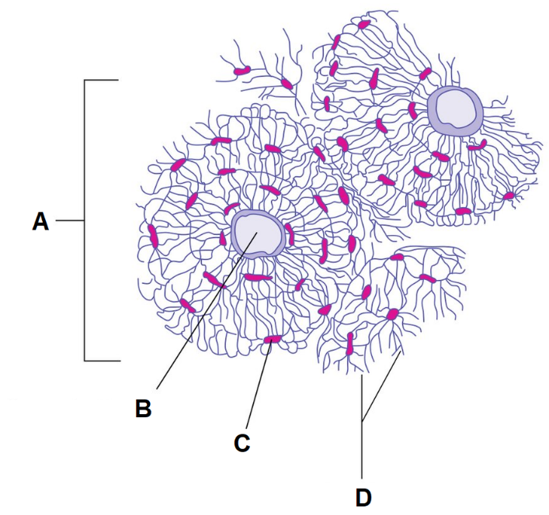

1. Transport of nutrients and wastes between osteocytes, shown at label D, occur through the
   1. lacunae.
   2. **canaliculi.**
   3. osteons.
   4. haversian canals.
2. Calcium is deposited by bone cells along with collagen to give bone its stiffness. Which of the following **correctly** identifies where this deposition occurs?
   1. Lamellae
   2. Periosteum
   3. Lacunae
   4. Haversian Canal

Questions 24 and 25 refer to the diagram below that shows the different organs associated with the digestive system.

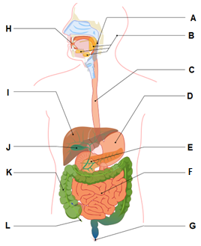

1. Achlorhydria is an autoimmune disease that damage parietal cells and can cause impaired digestion of food. In which organ would these cells be found?
   1. **Organ D**
   2. Organ E
   3. Organ F
   4. Organ J
2. Which of the following is **not** a function of the organ labelled K?
   1. Absorption of water and vitamins
   2. Formation and storage of faeces
   3. Breakdown of organic matter
   4. **Production of enzymes for chemical digestion**
3. Coenzyme Q10 is required for the synthesis of adenosine triphosphate. Which of the following **best** explains how a coenzyme works?
   1. Small organic and inorganic molecules that bind to the enzyme and change the shape of the active site
   2. Large protein molecules that permanently bind to enzymes and act as catalysts
   3. **Organic molecules that temporarily bind to an enzyme and change their shape**
   4. Inorganic molecules that produce chemical reactions between enzymes and substrates
4. Which of the following **best** explains why eating less fat can help with weight loss?
   1. **Fats are nutrient dense, producing the most energy.**
   2. Fats are associated with heart disease and therefore less exercise.
   3. Fats are used to create more cells in the body.
   4. Fats are metabolised slower than other nutrients.
5. Pulmonary hypertension (high blood pressure), causes the blood vessels of the lungs to become narrowed or blocked. Although there is no cure, treatment can be given to help reduce the symptoms. Which of the following would you **not** expect to be a symptom of pulmonary hypertension?
   1. Chest pressure and/or pain
   2. Cyanosis (blue lips)
   3. **Decreased heart rate**
   4. Shortness of breath
6. A scientist receives a histopathology report regarding a patient with polychondritis, which causes recurrent episodes of inflammation within cartilage. The sample, taken from the trachea, was glossy in appearance, with no visible fibres present, and contained clusters of chondrocytes. Which of the following types of cartilage is this sample representative of?
   1. Fibrocartilage
   2. **Hyaline**
   3. Connective
   4. Elastic
7. The lymphatic structure which absorbs lipids into the intestine is known as a
   1. **lacteal**
   2. lymphatic duct.
   3. collecting vessel.
   4. vein.

**End of Section One**

**This page has been left blank intentionally**

**Section Two: Short answer 50% (107 Marks)**

This section has **7** questions. Answer **all** questions. Write your answers in the spaces provided.

Supplementary pages for planning/continuing your answers to questions are provided at the end of this Question/Answer booklet. If you use these pages to continue an answer, indicate at the original answer where the answer is continued, i.e. give the page number.

Suggested working time: 90 minutes.

**Question 31 (17 marks)**

Chronic fatigue is most common in people between 40 and 60 years of age. D-ribose supplementation helps chronic fatigue by providing a substrate for cellular respiration to occur.

1. Complete the word equation for cellular respiration which uses glucose as its substrate. (1 mark)

|  |  |
| --- | --- |
| **Description** | **Mark** |
| Glucose + Oxygen 🡪 Water + Carbon Dioxide + ATP | 1 |
| **Total** | **1** |

1. Is the equation in part (a) an example of a catabolic or anabolic reaction? Justify your answer. (2 marks)

|  |  |
| --- | --- |
| **Description** | **Mark** |
| Catabolic | 1 |
| A larger molecule is broken down into smaller ones / transfer energy from complex molecules to ATP | 1 |
| **Total** | **2** |

1. Wastes produced from cellular respiration need to be excreted from the body. Identify which organ carbon dioxide is excreted from and describe how it is transported there.

(5 marks)

|  |  |
| --- | --- |
| **Description** | **Mark** |
| Lungs | 1 |
| in the blood/cardiovascular system/blood vessels | 1 |
| either bound to haemoglobin/carbaminohaemoglobin | 1 |
| as bicarbonate ion (HCO3-) in the plasma or | 1 |
| dissolved directly into the blood/plasma | 1 |
| **Total** | **5** |

A study in Great Britain found that 70% of patients suffering from Chronic Fatigue Syndrome had irregular mitochondrial structures.

1. Explain why an abnormal inner membrane of a mitochondria could lead to symptoms of fatigue. (5 marks)

|  |  |
| --- | --- |
| **Description** | **Mark** |
| site of electron chain transport | 1 |
| which produces most of the ATP | 1 |
| abnormal inner membrane will result in less ATP | 1 |
| causing metabolism/cell function to be reduced | 1 |
| resulting in bodily functions reducing/slowing down | 1 |
| **Total** | **5** |

1. During exercise, chronic fatigue patients often experience a burning sensation in their muscles along with a lack of strength. Explain why this occurs. (4 marks)

|  |  |
| --- | --- |
| **Description** | **Mark** |
| Lack of/limited oxygen supply | 1 |
| Anaerobic respiration takes place | 1 |
| Lactic acid is produced | 1 |
| Less ATP is produced | 1 |
| **Total** | **4** |

**Question 32 (12 marks)**

The diagram below shows a cross section of an organ within the digestive system.

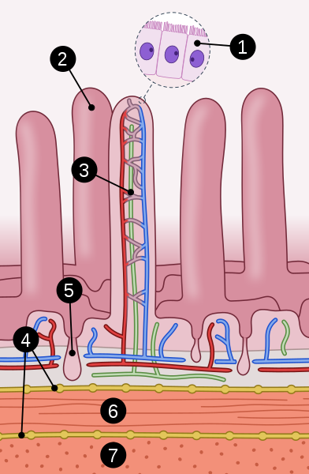

1. Identify the organ of the digestive system illustrated in the diagram above. Justify your answer. (2 marks)

|  |  |
| --- | --- |
| **Description** | **Mark** |
| Small intestine | 1 |
| Presence of villi/contains lacteals | 1 |
| **Total** | **2** |

1. Name the cell identified by label 1 and explain why these cells are lined with microvilli. (3 marks)

|  |  |
| --- | --- |
| **Description** | **Mark** |
| Enterocyte / epithelial cell | 1 |
| Increase surface area | 1 |
| for absorption | 1 |
| **Total** | **3** |

1. Describe the shape and appearance of the muscle cells you would find in this digestive organ, as identified by labels 6 and 7. (3 marks)

|  |  |
| --- | --- |
| **Description** | **Mark** |
| Single | 1-3 |
| Uninucleate |
| No striations / smooth |
| Tapers at each end/fusiform |
| **Total** | **3** |

1. Describe how the longitudinal and circular (transverse) muscles move ingested food through the digestive system. (4 marks)

|  |  |
| --- | --- |
| **Description** | **Mark** |
| Peristalsis | 1 |
| occurs in waves | 1 |
| circular contracts behind | 1 |
| longitudinal relaxes in front | 1 |
| **Total** | **4** |

**Question 33 (17 marks)**

In 2010, a patient at Westmead hospital in New South Wales, Australia, received the incorrect blood during a transfusion resulting in an ABO incompatibility reaction.

1. Describe how type A and type B blood types differ. (4 marks)

|  |  |
| --- | --- |
| **Description** | **Mark** |
| Type A has A antigens | 1 |
| Type B has B antigens | 1 |
| Type A has B antibodies | 1 |
| Type B has A antibodies | 1 |
| **Total** | **4** |

1. Describe what occurs to the newly transfused blood during an ABO incompatibility reaction. (1 mark)

|  |  |
| --- | --- |
| **Description** | **Mark** |
| Erythrocytes/RBCs agglutinate/clump together/coagulate | 1 |
| **Total** | **1** |

1. Treatment of ABO incompatibility reactions aim to prevent kidney failure. The presence of glucose in the urine suggests decreased function of the kidneys. Identify the part of the nephron that is responsible for glucose reabsorption.

(1 mark)

|  |  |
| --- | --- |
| **Description** | **Mark** |
| Proximal convoluted tubule | 1 |
| **Total** | **1** |

The loop of Henle creates an osmotic gradient throughout the nephron, which helps increase the reabsorption of water and ions.

1. State where in the kidney the loop of Henle is found and describe what would occur when a large volume of water is ingested. (3 marks)

|  |  |
| --- | --- |
| **Description** | **Mark** |
| Medulla/medullary pyramid | 1 |
| Osmotic gradient would decrease | 1 |
| Less water reabsorbed/more water excreted | 1 |
| **Total** | **3** |

Movement of substances, such as water and ions, can occur through several different processes.

1. Compare and contrast the processes of simple and facilitated diffusion. (4 marks)

|  |  |
| --- | --- |
| **Description** | **Mark** |
| Any two of the following for 1 mark each: | |
| * Passive process/does not use ATP/energy * Occurs along the concentration gradient/moves from higher to lower concentrations * When equilibrium is reached, net movement stops | 1-2 |
| Any two of the following rows for 1 mark each: | |
| |  |  | | --- | --- | | **Simple Diffusion** | **Facilitated Diffusion** | | Occurs through phospholipid bilayer/directly through cell membrane | Occurs through channel and/or carrier proteins/transmembrane proteins/facilitator molecules | | Transports small molecules/non-polar molecules | Transports small and large molecules/polar particles | | Rate of diffusion is related to concentration gradient and/or permeability | Rate of diffusion is related to kinetics of carrier-mediated transport | | 1-2 |
| **Total** | **4** |

1. Another symptom of kidney failure is high levels of urea in the blood. Explain how urea is formed. (4 marks)

|  |  |
| --- | --- |
| **Description** | **Mark** |
| Deamination/removal of an amino group | 1 |
| Produces ammonia | 1 |
| Which is combined with CO2 | 1 |
| Enzymes/urea cycle converts to urea | 1 |
| **Total** | **4** |

**Question 34 (17 marks)**

Covid-19 leads to blood clots in an estimated 30% of critically ill patients.

1. Identify the component of blood that is associated with clotting and give a reason why it is important that blood clots. (2 marks)

|  |  |
| --- | --- |
| **Description** | **Mark** |
| Platelets/thrombocytes | 1 |
| One of the following for 1 mark: | |
| * prevent the loss of blood * prevent infection * allow healing | 1 |
| **Total** | **2** |

The inferior view of a heart, which has been dissected horizontally across its short axis, is shown below.

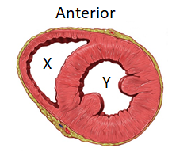

1. Identify the section labelled X and explain why its structure differs to that of the section labelled Y. (3 marks)

|  |  |
| --- | --- |
| **Description** | **Mark** |
| Right ventricle | 1 |
| Requires lower pressure/Only pumps to lungs/does not need to pump around the body | 1 |
| Whereas Y pumps to the entire body/requires higher pressure | 1 |
| **Total** | **3** |

1. Covid-19 has also been shown to cause enlargement of the heart muscles. Describe how this would affect the structure and function of the section labelled Y.

(3 marks)

|  |  |
| --- | --- |
| **Description** | **Mark** |
| decreased lumen/space for blood | 1 |
| reduced pumping ability | 1 |
| less blood pumped around the body | 1 |
| **Total** | **3** |

1. Identify and contrast the two main types of blood vessels in the human body.

(5 marks)

|  |  |
| --- | --- |
| **Description** | **Mark** |
| Veins and Arteries | 1 |
| Any four rows of the following for 1 mark each: | |
| |  |  | | --- | --- | | **Veins** | **Arteries** | | Carry blood to the heart | Carry blood away from heart | | Large lumen | Small lumen | | Thin/less elastic walls | Thick/elastic/muscular walls | | Slow/low pressure blood flow | Fast/high pressure blood flow | | Deoxygenated (except pulmonary vein) | Oxygenated (except pulmonary artery) | | Valves | No valves | | 1-4 |
| **Total** | **5** |

Stenosis refers to the abnormal narrowing of a blood vessel or other tube-like organ in the body.

1. State **one** lifestyle factor that may cause stenosis within the cardiovascular system and briefly outline the effects of this disease on the body. (4 marks)

|  |  |
| --- | --- |
| **Description** | **Mark** |
| Lifestyle: any one of the following for 1 mark: | |
| High fat/cholesterol diet | 1 |
| Smoking |
| Lack of exercise/sedentary lifestyle |
| Effect: any three of the following for 1 mark each: | |
| reduced/restrict blood circulation | 1-3 |
| less oxygen and nutrients reaching tissues/cells/organs |
| poor removal of wastes from tissues/organs |
| increases blood pressure/damages heart and/or vital organs |
| **Total** | **4** |

**Question 35 (14 marks)**

The diagram below illustrates a simplified version of an animal cell.

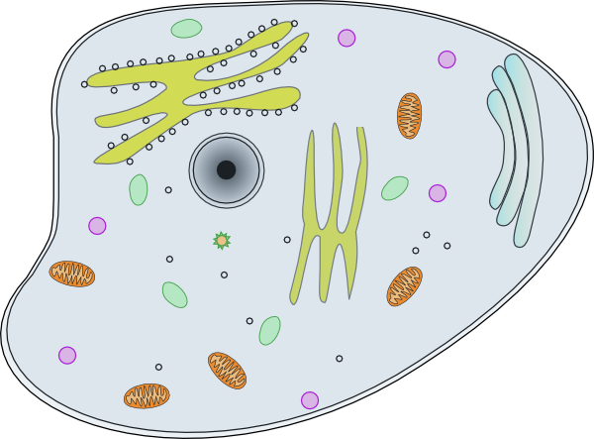

**Lysosome**

**C**

**E**

**B**

**As**

**D**

1. Identify the following organelles from the diagram above: (2 marks)

|  |  |
| --- | --- |
| **Description** | **Mark** |
| C: Mitochondria | 1 |
| E: Smooth Endoplasmic Reticulum | 1 |
| **Total** | **2** |

1. Describe how Organelle A and Organelle D work together to create lysosomes.

(2 marks)

|  |  |
| --- | --- |
| **Description** | **Mark** |
| Lysosomes are formed in Organelle D/Golgi body/network/apparatus | 1 |
| Enzymes within the lysosome are formed in Organelle A/rough endoplasmic reticulum | 1 |
| **Total** | **2** |

1. Describe the relationship between body systems and specialised cells. (3 marks)

|  |  |
| --- | --- |
| **Description** | **Mark** |
| Specialised cells join to form tissues / groups of cells organised together for a specific function creates a tissue | 1 |
| Different/two or more tissues join to form organs | 1 |
| Different organs work together to form organ systems | 1 |
| **Total** | **3** |

A group of Year 11 students were asked to investigate the effect of surface area to volume ratio on the exchange of materials across a cell membrane.

1. Complete the following table by calculating the missing values. (3 marks)

|  |  |
| --- | --- |
| **Description** | **Mark** |
| Each answer worth 1 mark: | |
| |  |  |  |  | | --- | --- | --- | --- | | **Length**  **of each side (mm)** | **Volume (mm3)** | **Surface Area (mm2)** | **SA: Vol ratio** | | 2 | 8 | 24 | **3:1** | | 4 | **64** | 96 | 3:2 | | 6 | 216 | **216** | 1:1 | | 1-3 |
| **Total** | **3** |

1. Explain the importance of cells being small. (4 marks)

|  |  |
| --- | --- |
| **Description** | **Mark** |
| Smaller the cell, larger SA: vol ratio | 1 |
| allows for faster diffusion/if ratio was smaller, diffusion would occur slower | 1 |
| cells require efficient removal of waste AND gain of nutrients to function | 1 |
| also affects speed of movement of materials within the cell | 1 |
| **Total** | **4** |

**Question 36 (17 marks)**

Digestion of proteins occurs in the stomach and small intestine through the activity of pepsin and trypsin enzymes, respectively.

1. Would you expect trypsin to have a higher or lower optimal pH level as compared to pepsin? Give a reason for your answer. (2 marks)

|  |  |
| --- | --- |
| **Description** | **Mark** |
| Higher | 1 |
| Environment of small intestine is less acidic/more alkaline  OR  does not contain hydrochloric acid like stomach | 1 |
| **Total** | **2** |

1. Enzymes are specific to certain molecules. Draw a labelled diagram to illustrate the lock and key model during an anabolic reaction. (4 marks)

|  |  |
| --- | --- |
| **Description** | **Mark** |
| Two substrates (both labelled) become one product (labelled) | 1 |
| Enzymes active site labelled AND matches substrate/s shape | 1 |
| Enzyme-substrate complex labelled | 1 |
| Resulting enzyme shows no change | 1 |
| Example: | |
|  | |
| **Total** | **4** |

1. Explain why biochemical pathways are multistep and controlled by specific enzymes.

(3 marks)

|  |  |
| --- | --- |
| **Description** | **Mark** |
| Any three of the following for 1 mark each: | |
| Regulate metabolites/products OR stop build-up of unwanted end products | 1-3 |
| Dependent on cell requirements/substrate availability |
| Less heat is produced/less energy is wasted |
| Maintain homeostasis/maintain constant set of conditions within cells |
| **Total** | **3** |

The enzyme catalase breaks down hydrogen peroxide (H2O2) to form water and oxygen. The reaction rate can be calculated by measuring the height of bubbles formed per second. The incomplete graph below shows the results of an experiment that investigated the effect of substrate concentration in percentage on the activity of catalase.

1. Using the data points from the graph, construct a table to illustrate the results.

(5 marks)

|  |  |
| --- | --- |
| **Description** | **Mark** |
| Title appropriate with both substrate concentration and reaction rate/enzyme activity | 1 |
| Substrate concentration/independent variable is in first column AND in numerical order | 1 |
| Column headings correct | 1 |
| Units only used in header row | 1 |
| Correct input of data | 1 |
| Example: | |
| Title: Effect of substrate concentration on reaction rate of catalase   |  |  | | --- | --- | | Substrate Concentration (%) | Reaction Rate (mm/sec) | | 0 | 0 | | 20 | 8 | | 40 | 12.5 | | 60 | 14 | | 80 | 14.5 | | 100 | 14.5 | | |
| **Total** | **5** |

1. Identify the saturation point for catalase in this experiment and describe how enzyme function is affected once saturation point is achieved.

(3 marks)

|  |  |
| --- | --- |
| **Description** | **Mark** |
| 80% | 1 |
| All available enzymes are working at their maximum rate | 1 |
| Any substrate increase has no effect on rate of reaction | 1 |
| **Total** | **3** |

**Question 37 (13 marks)**

1. It is often said that a broken bone is better than a tear in cartilage. Discuss why bone heals faster than a tear in cartilage. (3 marks)

|  |  |
| --- | --- |
| **Description** | **Mark** |
| Bone is vascular/contains blood vessels | 1 |
| Cartilage does not contain blood vessels/is avascular |
| Osteoblast activity/metabolism is greater | 1 |
| Chondrocyte activity/metabolism/cell division/repair is slow |
| Bone contains more osteoblasts (bone building cells) than chondrocytes (cartilage building cells) | 1 |
| Cartilage healing depends on diffusion which takes time/is slow |
| **Total** | **3** |

1. State the differences in structure between compact and spongy bone. (3 marks)

|  |  |
| --- | --- |
| **Description** | **Mark** |
| Any three of the following comparisons for 1 mark each: | |
| Compact bone contains a central canal, but spongy bone does not | 1-3 |
| Spongy bone is less dense than compact bone |
| Blood vessels and/or nerves run down central/haversian canal in compact bone, but through the spaces within spongy bone |
| Compact bone is regular in its arrangement, but spongy bone is irregularly arranged |
| Spongy bone contains red bone marrow whilst compact bone does not |
| **Total** | **3** |

1. The following diagram illustrates the structure of a knee joint.

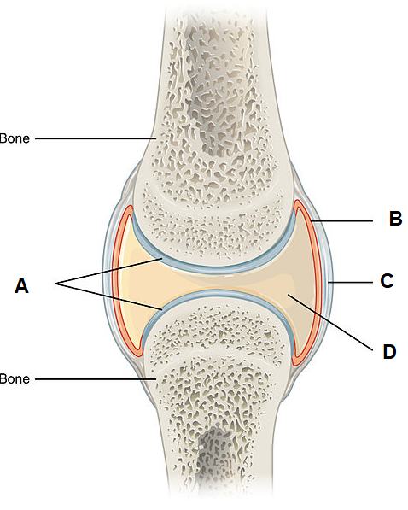

1. State the name given to this type of joint in the body. (1 mark)

|  |  |
| --- | --- |
| **Description** | **Mark** |
| Synovial joint / hinge joint | 1 |
| **Total** | **1** |

1. Briefly describe how the structures labelled B and D prevent injury to these types of joints. (2 marks)

|  |  |
| --- | --- |
| **Description** | **Mark** |
| Structure B/synovial membrane produces structure D/synovial fluid | 1 |
| Cushions the joint (against impact) | 1 |
| Reduces friction |
| Lubricates the joint |
| Prevents moving surfaces from touching each other |
| **Total** | **2** |

1. Complete the table below to identify the specific type of joint illustrated and provide **one** location for each.

(4 marks)

|  |  |
| --- | --- |
| **Description** | **Mark** |
| |  |  |  | | --- | --- | --- | |  |  |  | | Type of joint: | Saddle | Hinge | | Location of joint: | Thumb | Elbow/knee/ankle/  fingers/toes | | 1-4 |
| **Total** | **4** |

**End of Section Two**

**Section Three: Extended answer 20% (40 Marks)**

Section Three consists of **four** questions.

Questions 38 and 39 are from Part 1. Question 40 and 41 are from Part 2. Answer **one** question from Part 1 and **one** question from Part 2.

Use black or blue pen for this section. Only graphs and diagrams may be drawn in pencil. Responses can include: labelled diagrams with explanatory notes; lists of points with linking sentences; labelled tables and/or graphs; and/or annotated flow diagrams with introductory notes.

Supplementary pages for planning/continuing your answers to questions are provided at the end of this Question/Answer booklet. If you use these pages to continue an answer, indicate at the original answer where the answer is continued, i.e. give the page number.

Suggested working time: 50 minutes.

**Part 1**

Choose **either** Question 38 **or** Question 39.

Indicate the question you will answer by ticking the box next to the question. Write your answer on pages 29 - 33. When you have answered your first question, turn to page 34 and indicate on that page the second question you will answer.

**Question 38 (20 marks)**

1. Smoking increases the risk of osteoporosis. Tobacco, one of the chemicals found in cigarettes, alters the activity of the cells associated with bone formation.

Differentiate between the cells associated with bone metabolism. Explain how osteoporosis develops and identify common symptoms of the disease.

(10 marks)

|  |  |
| --- | --- |
| **Description** | **Mark** |
| Cells associated with bone metabolism are osteoblasts and osteoclasts | 1 |
| 3 of the following comparisons. One mark per row. | |
| |  |  | | --- | --- | | *Osteoclast* | *Osteoblast* | | Associated with breakdown of bone/bone resorption | Associated with building of bone/remodelling of bone | | Large cells | Small cells | | Multinucleated cells | Mononucleated cell | | Do not become osteocytes | Become osteocytes | | Release calcium into blood | Deposit calcium into bone | | 1-3 |
| Any 4 of the following for one mark each: (explanation) | |
| * imbalance between bone formation and reabsorption / body does not form enough new bone / body reabsorbs too much old bone / osteoclasts more active than osteoblasts | 1-4 |
| * increase loss of calcium/minerals from the bones |
| * reduction in number of osteocytes |
| * thinning (or loss) of the connecting bone/trabeculae (in spongey bone) |
| * increase in size and number of haversian canals (in cortical bone) / endosteum thins |
| * density of bone decreases |
| * bones become porous and fragile/weaker |
| Any two of the following for one mark each: (symptoms) | |
| * loss of >3cm in height over time | 1-2 |
| * hunched over/stooped posture |
| * bone pain/tenderness / back pain |
| * easier than usual bone fracturing |
| **Total** | **10** |

1. The normal heart rate for a healthy adult at rest is 60 to 70 beats per minute. Irregular heartbeats, such as during a heart attack, can affect the flow of blood through the heart and may even result in death.

Describe how blood normally flows through the heart and explain the effect on blood flow in the heart if the valve between the left atrium and ventricle was ineffective. (10 marks)

|  |  |
| --- | --- |
| **Description** | **Mark** |
| Any 8 of the following for 1 mark each. Max 6 if not in the correct order. | |
| Blood enters the right atrium | 1-8 |
| through the vena cavae/superior and inferior vena cavae |
| Blood flows through tricuspid valve |
| Into the right ventricle |
| Past the pulmonic valve/semilunar valve |
| into pulmonary artery |
| Oxygenated blood returns via pulmonary veins |
| Into the left atrium |
| Through the mitral valve/biscupid |
| Into the left ventricle |
| Past the aortic valve/semilunar valve |
| Into the aorta |
|  | |
| Blood flows backwards / blood would flow from ventricle to atrium | 1 |
| Less oxygenated blood would flow to the body | 1 |
| **Total** | **10** |

**Question 39 (20 marks)**

1. Filaments are long chains of proteins found in muscles and connective tissue that produce movement of body parts.

Identify the filaments associated with the musculoskeletal system and outline how they are involved in producing movement.

(10 marks)

|  |  |
| --- | --- |
| **Description** | **Mark** |
| Identification of the filaments, one mark each: | |
| actin | 1 |
| myosin | 1 |
| collagen | 1 |
| Production of movement for muscles: | |
| actin and myosin are arranged in sarcomeres | 1-4 |
| influx of Ca2+ exposing binding sites |
| actin and myosin form crossbridge / myosin head binds to actin |
| power stroke uses ATP |
| myosin pulls actin towards sarcomere centre |
| sarcomere shortens/contracts causing movement |
| Production of movement for connective tissue: | |
| Tendons are made of connective tissue | 1 |
| Muscles connect to bone via tendons | 1 |
| When the muscle contracts, the bone is pulled | 1 |
| **Total** | **10** |

1. The ketogenic diet is based on the premise that an intake of low-carbohydrate, high-fat foods will promote weight loss.

Explain how fats are digested in the small intestine and describe why a diet low in carbohydrates can be dangerous.

(10 marks)

|  |  |
| --- | --- |
| **Description** | **Mark** |
| Digestion of fats. 8 of the following for one mark each: | |
| intestinal juices secreted by glands in the lining | 1-8 |
| pancreatic juices produced and secreted by the pancreas |
| both contain the enzyme lipase |
| chemically digests fats |
| into fatty acids and glycerol |
| liver produces bile |
| that is stored in the gallbladder |
| emulsifies fat / break fat into small/tiny droplets |
| mechanical digestion that increase surface area |
| muscular contractions of the small intestine churn food |
| Importance of carbohydrates: | |
| preferred energy source / immediate energy source | 1 |
| Low-carb diet causes lack of energy | 1 |
| can result in weakness / dizziness / headaches / nausea etc. |
| **Total** | **10** |

**Part 2**

Choose **either** Question 40 **or** Question 41.

Indicate the question you will answer by ticking the box next to the question. Write your answer on the pages provided.

**Question 40 (20 marks)**

1. Alzheimer’s is a degenerative brain disease that is thought to be the result of plaque sticking to the neurons of the brain and compromising the cell membrane.

Outline the structure of the cell membrane and describe how plaque deposits could affect the function of nervous tissue.

(10 marks)

|  |  |
| --- | --- |
| **Description** | **Mark** |
| Structure of cell membrane. Any 8 of the following for one mark each: | |
| Fluid mosaic model | 1-8 |
| Composed of phospholipid molecules |
| Arranged in a bilayer/two layers |
| Hydrophilic heads |
| Hydrophobic tails |
| Protein and/or cholesterol molecules embedded in bilayer |
| Receptor proteins |
| Channel proteins |
| Carrier proteins |
| Cell-identity markers |
| Function of nervous tissue. | |
| Stop/decrease the transmission of (electrical) messages/signals throughout the body | 1-2 |
| Stop/decrease coordination/control of bodily activities |
| Stop/decrease the ability to detect changes in the environment |
| Stop/decrease movement of substances in/out of the cell |
| **Total** | **10** |

1. Asthma is a chronic (long-term) condition that affects the airways. Inflammation of the airways, along with excess mucus production, results in the narrowing of the bronchioles and increased difficulty to exhale.

Outline the process of exhalation and explain how asthma affects gas exchange.

(10 marks)

|  |  |
| --- | --- |
| **Description** | **Mark** |
| Process of exhalation. | |
| Intercostal muscles relax | 1-5 |
| Rib cage moves down and inwards |
| Diaphragm relaxes |
| Diaphragm moves up into chest cavity |
| Lung volume decreases |
| air pressure inside lungs increases |
| Air flows from lungs to outside | 1 |
| Gas Exchange: | |
| reduced gas exchange | 1 |
| decreased concentration gradient / high concentration gradient not maintained | 1 |
| more air trapped in lungs and not exhaled | 1-2 |
| decreased amount of oxygen entering the alveoli |
| increased levels of carbon dioxide in the alveoli |
| reduced volume of air moving in and out of lungs |
| **Total** | **10** |

**Question 41 (20 marks)**

1. Kidney stones, which are crystals of uric acid, can form in the renal pelvis. One symptom associated with damage caused by kidney stones is the presence of proteins in the urine.

State how uric acid is produced and outline the route a kidney stone will take to be excreted. Explain why protein in the urine would be a sign that kidney stones have caused damage to the kidney.

(10 marks)

|  |  |
| --- | --- |
| **Description** | **Mark** |
| Kidney stones: | |
| Metabolism of purines/DNA & RNA/nucleic acids | 1 |
| From renal pelvis through to ureter | 1 |
| into the bladder | 1 |
| out through the urethra | 1 |
| Proteinuria: | |
| filtration occurs in glomerulus | 1-6 |
| proteins normally too large/negatively charged so cannot be filtered/impermeable |
| presence of proteins suggests damage to glomerulus |
| proteins move into Bowman’s capsule/filtrate |
| damage to proximal tubule can also result in protein in urine |
| as reabsorption of amino acids occurs here |
| **Total** | **10** |

1. Water intoxication is a potentially deadly condition arising from excessive water intake.

Briefly describe where water is absorbed in the digestive system. Explain the effect of excess water consumption on the cells of the body.

(10 marks)

|  |  |
| --- | --- |
| **Description** | **Mark** |
| Water is absorbed in the:   * stomach, * small intestine and * large intestine/colon | 1-3 |
| Interstitial fluid/extracellular fluid becomes dilute/hypotonic | 1-4 |
| Low amount of solutes/electrolytes/sodium in interstitial fluid/ extracellular fluid |
| compared to outside the cells/higher amount of solutes/electrolytes/ sodium inside cell |
| Water concentration gradient is increased |
| water moves/osmosis/diffuses into the cell/cells take on water |
| cells begin to bloat/swell | 1 |
| as more water moves into the cell it eventually bursts/lyses | 1 |
| cell function decreases | 1 |
| **Total** | **10** |

**End of Questions**

**Acknowledgements**

**Question 5 – 7** Bruce Blaus. (2017). Illustration of bicep curl [image]. Retrieved October, 2020, from: <https://commons.wikimedia.org/wiki/File:Exercise_Bicep_Curls.png>

**Question 10** Gal, M. (2007). Graph of Enzyme Activity against Temperature [image]. Retrieved September 2020, from:

<https://commons.wikimedia.org/wiki/File:Enzyme-temperature.png>

**Question 15** Paola it. (2017). Human Skull [image]. Retrieved October, 2020, from: <https://commons.wikimedia.org/wiki/File:Human_skull_nocolors.svg>

**Question 16** Adapted from OpenStax College (2013). Summary of Epithelial Tissue [image]. Retrieved October, 2020, from: <https://commons.wikimedia.org/wiki/File:423_Table_04_02_Summary_of_Epithelial_Tissue_CellsN.jpg>

**Question 18 – 19** JeeJeederivative work: Marek M. (2011). Myofibril diagram [image]. Retrieved October, 2020, from: <https://commons.wikimedia.org/wiki/File:Myofibril_diagram.svg>

**Question 22 – 23** Adapted from Bartleby (2006). Transverse section of Bone [image]. Retrieved October, 2020, from: <https://commons.wikimedia.org/wiki/File:Diagram_of_an_osteocyte_-_a_type_of_bone_cell_CRUK_031.svg>

**Question 24 – 25** Adapted from Termininja (2012). Digestive System [image]. Retrieved October, 2020, from: <https://commons.wikimedia.org/wiki/File:Digestive_system.svg>

**Question 32** Kebert, T. (2020). Small intestine surface [image]. Retrieved September, 2020, from: <https://commons.wikimedia.org/wiki/File:Small_intestine_surface.svg>

**Question 34** Patrick J. Lynch. (2006). Heart normal short axis [image]. Retrieved September, 2020, from: <https://commons.wikimedia.org/wiki/File:Heart_normal_short_axis_section.jpg>

**Question 35** Shared by OCAL. (2010). Animal Cell Clip Art [image]. Retrieved October, 2020, from: <http://www.clker.com/clipart-animal-cell.html>

**Question 36** ttsz. (2017). Enzyme, Lock and Key Model, Synthesis [image]. Retrieved October, 2020, from: <https://www.istockphoto.com/vector/enzyme-lock-and-key-model-synthesis-gm665215350-121161975>

**Question 37** OpenStax College. (2013). Synovial Joint [image]. Retrieved October, 2020, from: <https://commons.wikimedia.org/wiki/File:907_Synovial_Joints.jpg>

**Question 37** Adapted from OpenStax College. (2013). Types of Synovial Joints. Retrieved October, 2020, from: <https://commons.wikimedia.org/wiki/File:909_Types_of_Synovial_Joints.jpg>